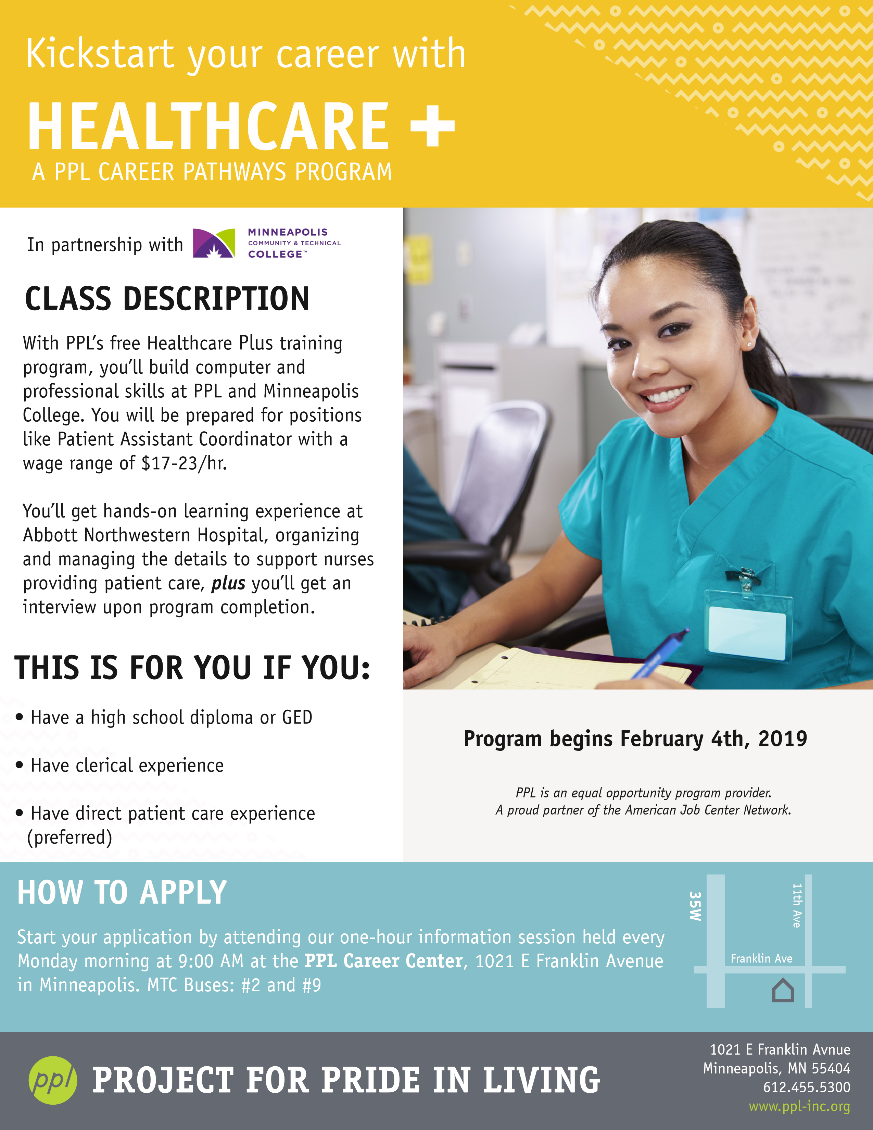

**Program begins February 19th, 2019**