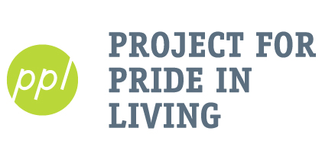
Resident Support Liason

PPL builds the hope, assets, and self-reliance of individuals and families who have lower incomes by providing transformative affordable housing and employment readiness services.

Organization: Project for Pride in Living (PPL)
Program: Family Supportive Housing
Site: PPL Administrative Building primary location (1035 E Franklin) In addition Various PPL Housing locations
Schedule: 10-20 hours/week; Sept-May
Supervisor: Mari Jo Long - Program Manager, Family Supportive Housing
Positions available: 1
FLSA Status: Unpaid

Summary: PPL serves individuals and families struggling with poverty, limited education, and other complex barriers. Mission: PPL builds the hope, assets, and self-reliance of individuals and families with lower incomes through transformative affordable housing and employment readiness services. Children and youth services are offered at Supportive Housing sites that serve families transitioning from homelessness.
Work with PPL residents in Minneapolis Family Supportive Housing (FSH) to improve the quality of services and increase participation in groups and family day activities. Resident Relations includes meeting with residents to get feedback on services such as family day, and resident groups then utilizing that feedback to create promote activities. In addition, it may include (re)creating a resident council and acting as a liaison with PPLs property managers.
Responsibilities:
- Develop trusting relationships with PPL residents using an asset-based, culturally inclusive, and trauma-informed approach.
- Facilitate listening feedback sessions 1:1 or in a group for residents to give input on PPL’s FSH services.
- Compile and analyze data into useful feedback that can be used to create and improve services.
- Promote and facilitate activities including a resident council.
- Work with residents to productively share concerns regarding property management and act as a liaison where appropriate.
- Communicate and coordinate services with all team members.
- Keep accurate and up to date documentation including but not limited to: case notes, incident reports, etc.

Qualifications:
- Self-starter and self-directed, ability to work independently on assigned projects
- Experience with program evaluation, data collection, research method, and analysis.
- Excellent communication, organization, time management, and problem-solving skills
- Dependable, responsible, flexible, patient
- Interest in work with people from diverse backgrounds and experiences.
- Experience with Word, Excel, Internet.

Application Process: Please direct questions and resumes/cover letters to Zarah Augustine at Zarah.augustine@ppl-inc.org. The process includes an interview, references and a background check for final candidates. Positions are open until filled.

